Quiz 3- Machine Programming I

Top of Form

**Timothy Beckett (username: tdb2q)**

**Attempt 1**

Written: Jun 6, 2023 6:49 PM - Jun 6, 2023 7:32 PM

**Submission View**

Released: Jun 9, 2023 7:00 AM

|  |  |  |
| --- | --- | --- |
| **Question 1** |  | 1 / 1 point |

least significant 8 bits of register rax is called

|  |  |
| --- | --- |
|  | al |
|  | ah |
|  | ax |
|  | cl |
| **Question 2** | |  | 1 / 1 point |

movq cannot be used to transfer data from memory to memory with a single instruction.

|  |  |  |  |
| --- | --- | --- | --- |
|  |  | True | |
|  |  | False | |
| **Question 3** | |  | 15 / 15 points | |

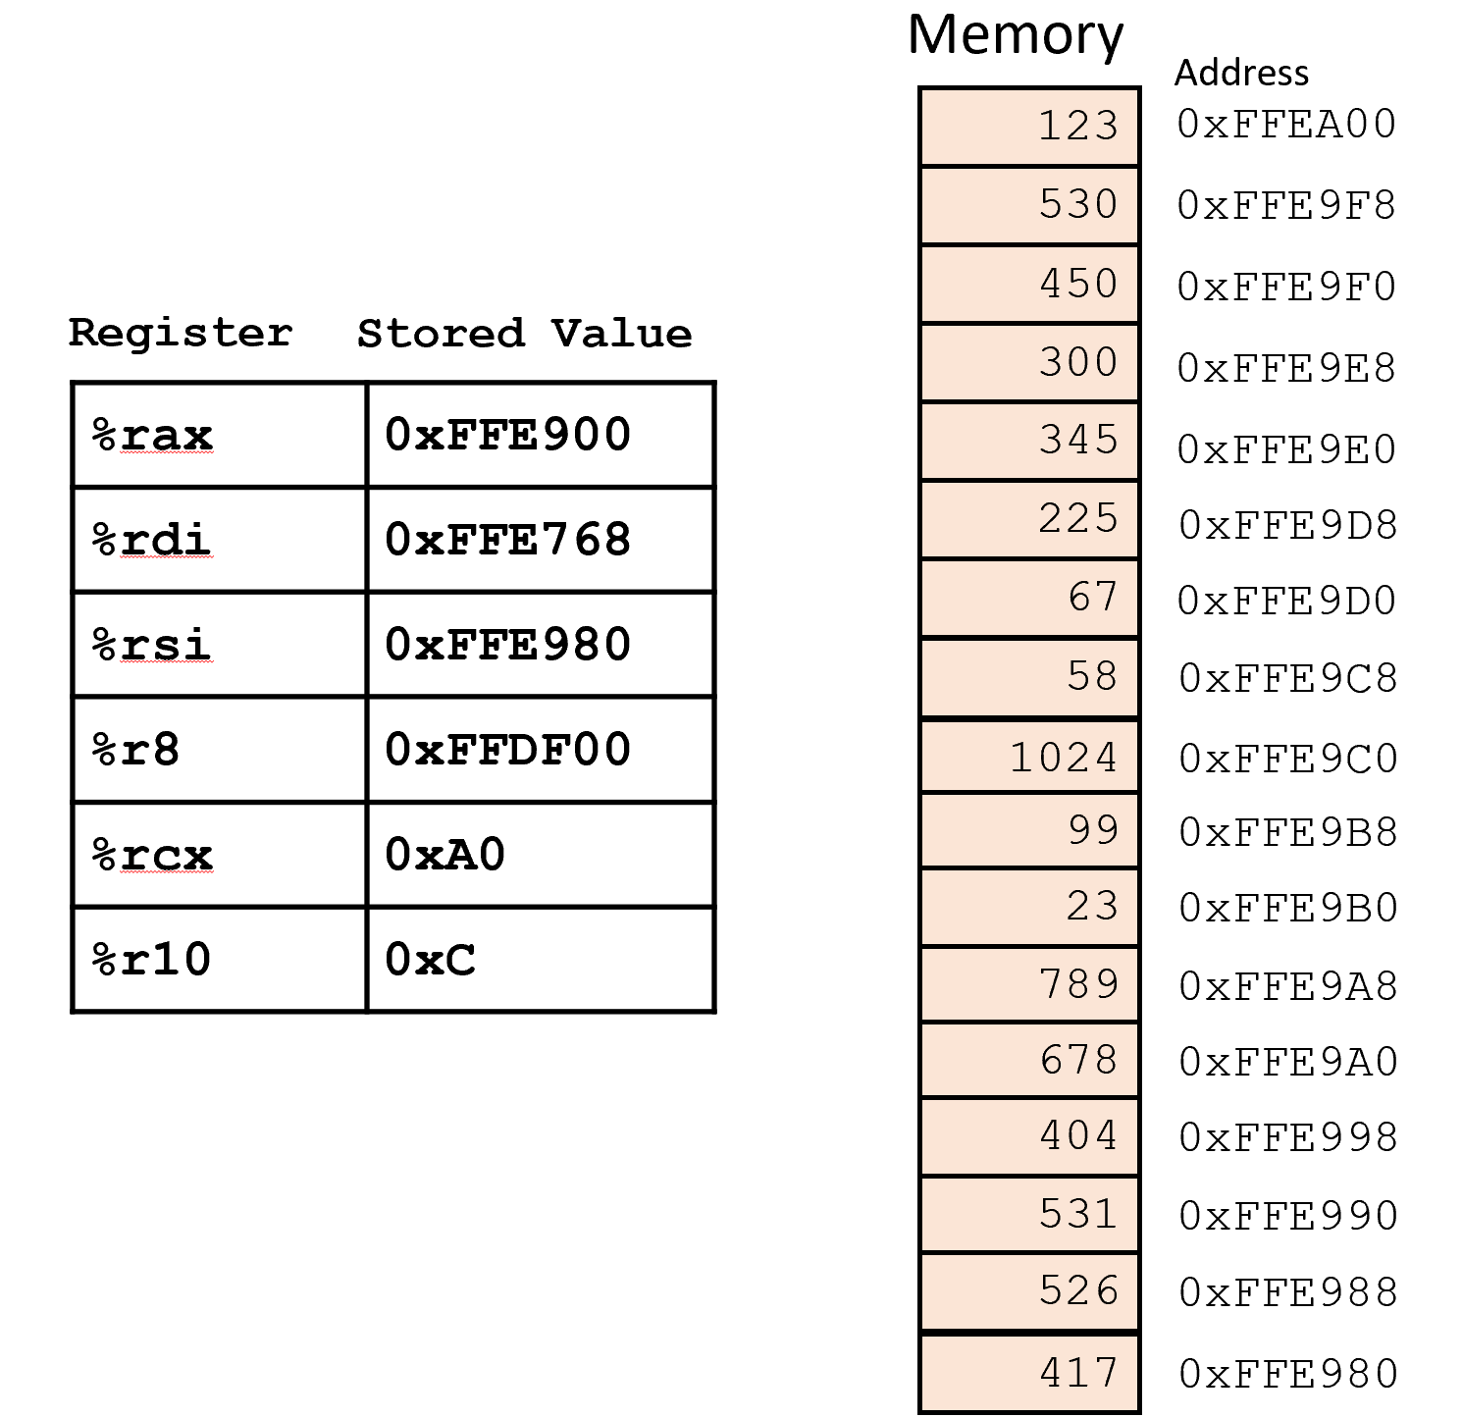

Based on above information compute the value stored in register rdx after the following instructions are executed.

a)movq 0xFFE900(%rcx,%r10,8), %rdx

___123___(20 %)

b)leaq (%rdi,%rcx,8), %rdx

___0xFFEC68___(20 %)

c)leaq 0x8(%rsi,%rcx), %rdx

___0xFFEA28___(20 %)

d)movq 0x5A8(%r8,%rcx,8), %rdx

___789___(20 %)

e)movq (%rax,%rcx), %rdx

___678___(20 %)

|  |  |  |
| --- | --- | --- |
| **Question 4** |  | 2 / 2 points |

Let's assume %ecx = 0x000FFD0E and %eax= 0x000FED25 (Hexadecimal representation). What is the value in %ecx after the following instruction?

orq %eax, %ecx

Provide answer in hexadecimal representation.

Acceptable answer format: 000003FD or 0x000003FD

|  |  |  |
| --- | --- | --- |
| Answer: | 0x000FFD2F |  |
| **Question 5** | | |  | 1 / 1 point |

Let's assume  %eax= 0x000FED25 (Hexadecimal representation). What is the value in %eax after the following instruction?

salq $4, %eax

Provide answer in hexadecimal representation.

Acceptable answer format: 000003FD or 0x000003FD

|  |  |  |
| --- | --- | --- |
| Answer: | 0x00FED250 |  |
|  |  | |
|  | | |

|  |
| --- |
| **Attempt Score:**  20 / 20 |
| **Overall Grade (last attempt):**  20 / 20 |

|  |
| --- |
|  |

Done

|  |
| --- |
|  |

Bottom of Form